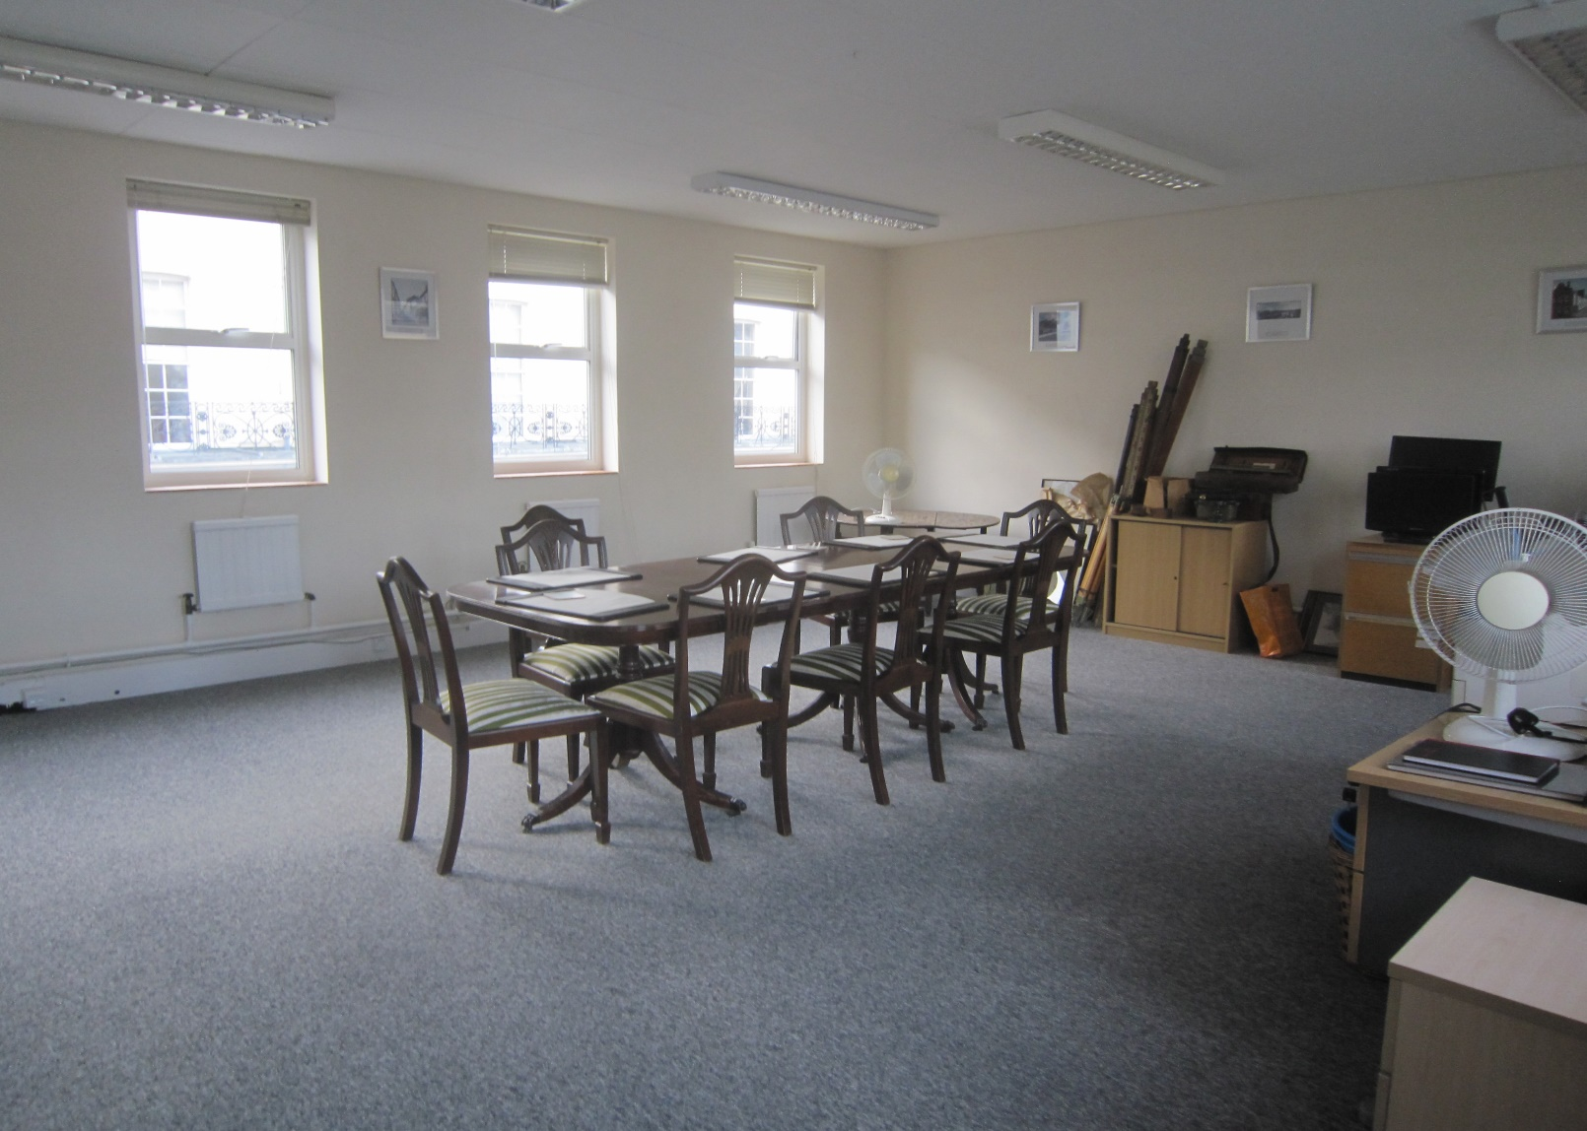
FIRST FLOOR OFFICE AVAILABLE TO LET - CAN BE DIVIDED
16.4-42.3 M²/177-456 SQ FT

Albion House
Albion Street
Lewes
East Sussex, BN7 2NF

LOCATION
Lewes, the County town of East Sussex, is locatied 8 miles to the north-east of Brighton at the junction of the A26 and A27. The town has a dual carriageway links to the M23 and a mainline railway station to London Victoria (65 minutes approx) as well as comprehensive bus services. The property stands in the School Hill area of the High Street on the corner of Albion Street and is within short walk of the main shopping area.

DESCRIPTION
The premises comprise a first floor office suite with use of a kitchenette and lift.

ACCOMMODATION
Accommodation available as one office, or can be divided to form two offices:

Room 1 42.43m2 (456sqft ) - entire suite
Room 1A 16.4m2 (177sqft ) - if room divided

Lease inclusive of service charge, exclusive of rates. Includes one car parking space for the larger office.

RATES
Please refer to the Local Authority for information on rates. 100% Small Business Relief available subject to certain conditions.

LEGAL FEES
Each party to be responsible for their own legal costs.

ENERGY PERFORMANCE CERTIFICATE
Energy Performance Rating C.

VAT
The property has not been elected for VAT.

TERMS
New sub-lease to be agreed for a minimum of 12 months at the following monthly payments inclusive of service charge. Heating, electricity, cleaning of common parts (except carpet) are included in the monthly payments.

Room 1 £750 pcm, exclusive of rates
Room 1A £385 pcm, exclusive of rates

VIEWING
Contact James Groves BSc MRICS or 01273 407920 or by e-mail: jgroves@clifforddann.co.uk

Neither the Lessor nor the Agents gives or implies any warranty that the premises are fit for any particular use or that they comply with any relevant regulation or statutory requirement. The agents have not tested any apparatus, equipment, fittings or services so cannot verify that they are in working order. The tenant is advised to obtain verification from their Solicitor or Surveyor before proceeding.

